**Identification of Risks**

Based on the Risk Table in Figure___, it can be observed that the most significant risk and impact would be the BMS IC not functioning as intended and the DC-DC converter not outputting a dual current to supply power to the low voltage electronics on the vehicle.

**BMS IC**

The BMS IC is intended to perform cell balancing, charging, discharging, and has battery protection features. The BMS IC poses the most significant risk because other PCB components were derived and selected partly because of their compatibility with the BMS IC (BQ76930). The BMS IC’s risk has been mitigated by reviewing the datasheet for the IC, as common application circuits are given, including supporting component values. Part of our research for our BMS IC has been selecting the BMS IC supporting component values, like current sense resistor resistance and FETS. The current sense resistor resistance and accompanying power for the BQ76930 by basing the bq76930EVM maximum voltage of 200 mV along with our expected dual current output and an accompanying power. A more detailed explanation of calculations to find current sense resistor( Rsns ) resistance and accompanying power is found below.

Rsns = $\frac{ Voltage(V) }{Current (I)}$ = $\frac{ Max Voltage of Rsns from bq76930EVM data sheet - 100mV buffer }{Dual output current ( in parallel) + 5 Amp buffer }$ = $\frac{ 200 mV - 100 mV }{10 Amps + 5Amps + 5 Amp buffer }$ = $\frac{100 mV }{20 Amps }$ = $\frac{1 }{2 }mOhms$

P = ${I^{2}R}^{}$ = ${(20 Amp)^{2}(}^{}$ $\frac{1 }{2 }mOhms$) $=2 Watts$

The bq76930EVM evaluation module (EVM) has the FET value we will need for our BMS IC. Initially, we considered procuring a bq76930EVM evaluation module (EVM) to evaluate the system for the BQ76930, a standard trade study to test the BMS IC functionality. The bq76930EVM comes with a pre-selected sense resistor, power and control of the output of FETS, and other onboard components necessary to protect the cells from overcharge, over-discharge, short circuit, and overcurrent discharge. However, procuring a bq76930EVM evaluation module was unrealistic because it was 250 dollars which would account for 1/4th of our budget. So, it was determined that more budget-conscious trade studies could be conducted by using the six existing 18650 lithium-ion battery cells on the GLV and procuring a BMS IC to begin performing functionality tests like charging and discharging. Therefore, we requested and received permission from our sponsor to request a PO(Purchase Order) for a BMS IC to begin testing.

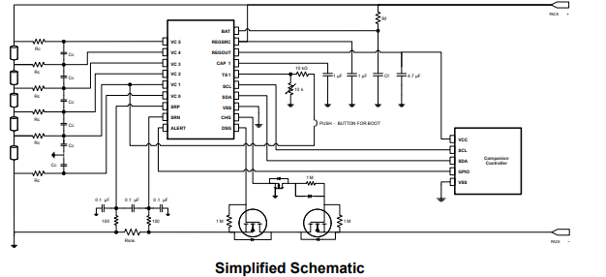

Figure_. BQ76930 Schematic with Rsns(current sense resistor) and FETS

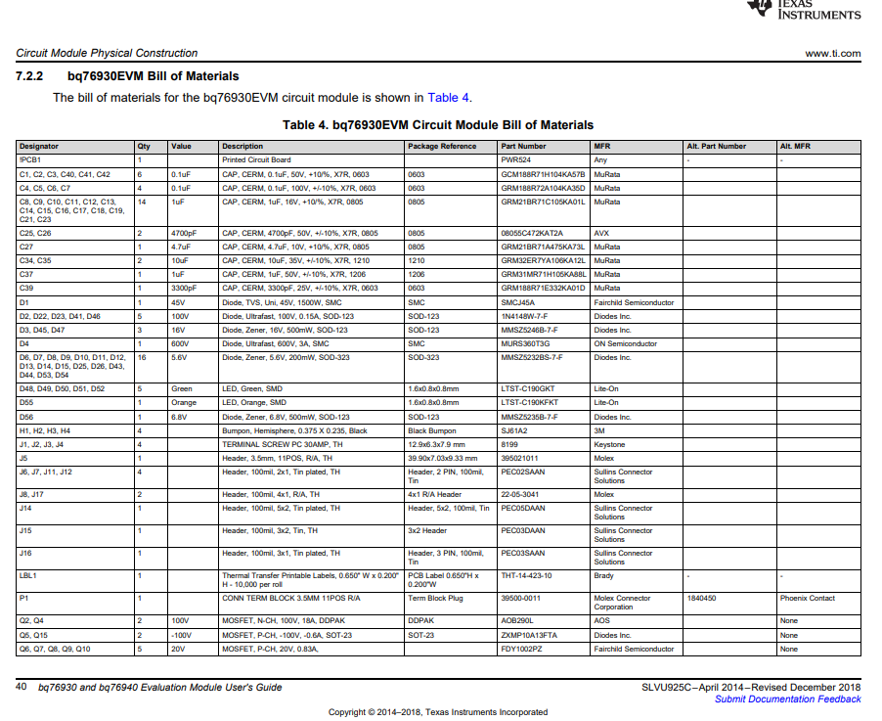

Figure,_. Bq76930 EVM has the FET AOB290L for our BQ76930

**DC-DC converter**

The conversion from battery voltage to separate voltage rails of 24V and 12V from supplying current to the low-voltage electronics on the vehicle is the main objective of our GLV project. We have already mitigated this as the team plans on using switching regulators(aka. Buck converters) as our DC-DC converter. We were also recommended installing ceramic filter caps to mitigate frequency concerns.